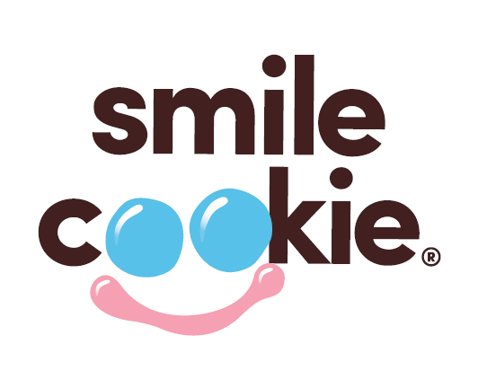 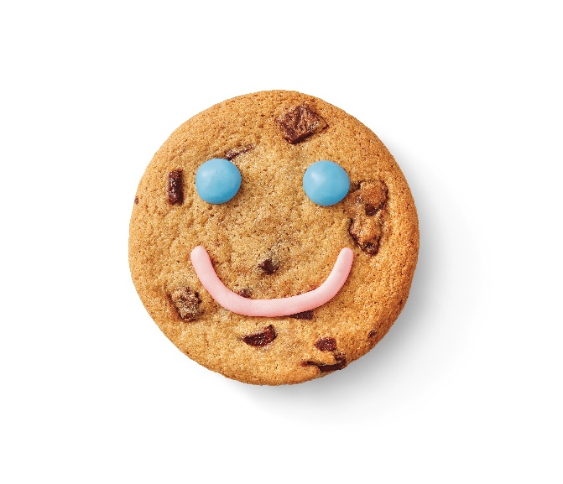

**Pre-Order Form**

**From April 28-May 4,** Tim Hortons Restaurant Owners will be supporting more than 600 local charities, hospitals and community programs across Canada. **Guests who purchase a freshly baked Smile Cookie will be donating to these great causes with 100% of proceeds being donated!** To pre-order Tim Hortons Smile Cookies, complete this form and submit it to your Tim Hortons Restaurant of choice no less than 48 hours of your specified pick-up date & time. Or visit the Tim Hortons app, Uber Eats, Door Dash or Skip the Dishes to see if your Smile Cookies can be delivered. **Cookies are $2 each and tax free when you order 6 or more!**

**Locations with Smile Cookie proceeds going to New Brunswick Social Pediatrics:**

* **52 King Street**
* **31 Waterloo Street**

|  |  |  |
| --- | --- | --- |
| **Number of Cookies:** |  |  |

|  |  |  |
| --- | --- | --- |
| **Your Name:** |  | |
| **Address:** |  | |
|  |  | |
| **Telephone:** |  |
| **Email:** |  |

|  |  |  |  |
| --- | --- | --- | --- |
| **Pick Up Date:** |  | **Pick Up Time**: |  |

**Thank you for your support!**